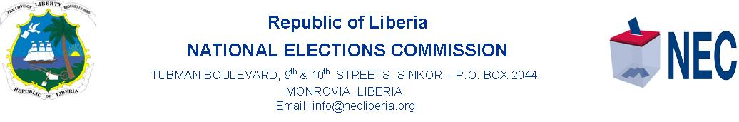
PRESS STATEMENT
NEC, ECC Hold Meeting on 2020 Elections
MONROVIA 8 October 2020 …… a three-member delegation from the Elections Coordinating Committee (ECC) Thursday 8 October 2020 paid a one-day visit to the National Elections Commission (NEC) to ascertain first-hand information on the status of the December 8, 2020 Special Senatorial Election (SSE), the Constitutional Referendum, and the By-elections of Sinoe and Montserrado Counties.
The ECC delegation was headed by its Coordinator, Oscar Bloh, while the NEC Chairperson Davidetta Browne Lansanah, Co-chairperson Cllr. Teplah Reeves, Commissioners Barsee Leo Kpankai, Floyd Oxley Sayor, and Cllr. Ernestine Morgan Awar represented the Commission.
Speaking Mr. Bloh said, “the ECC came to get first-hand information relating to the conduct of the three elections on 8 December 2020”. Mr. Bloh said “the ECC is concerned about the outcome of the just ended Voter Roll Update and worried about the conduct of a free, fair, credible, and transparent election and want to know the challenges facing the Commission and what can be done to remedy the challenges”.
Responding, the Chairperson Browne Lansanah said, “the Commission has no doubts that the Government of Liberia will provide the necessary funding needed to conduct the SSE and Referendum, and the two by-elections all slated for 8 December 2020”.
Chairperson Browne Lansanah said “all of the procurement processes are going according to plan and that with the level of commitment from the Liberian government to provide the needed funding, the elections will be conducted on December 8, 2020.
The NEC Boss said “to fulfill the aspirations of all Liberians for a free, fair, credible, and transparent elections on 8 December 2020, and the Commission’s desire to ensure transparency and commitment to meet the aspiration of the Liberians, a copy of the Final Registration Roll (FRR) will be given to registered Political Parties, key Civil Society Groups, as well as members of the International Community for counterchecking purposes”.
Signed By: ________________________ .
Henry Flomo
Communications Director

